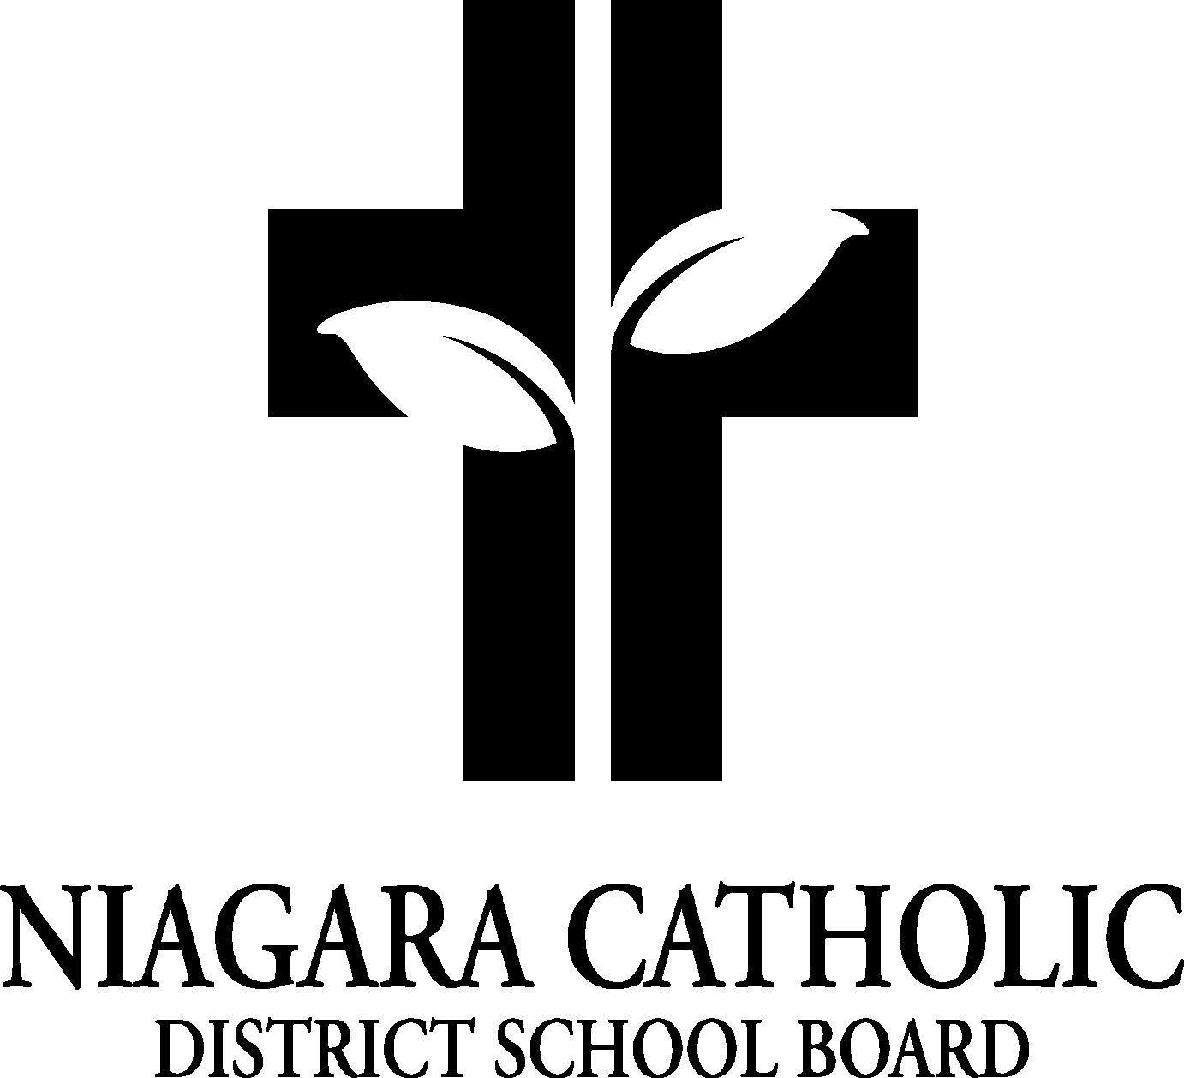

MINUTES OF THE
ST. JOSEPH CATHOLIC SCHOOL COUNCIL MEETING

February 26, 2014

Minutes of the Meeting of the St. Joseph Catholic School Council, held on February 26, 2014 at 6:30 pm.

The meeting was called to order at 6:30 pm by Chair Mrs. Watchorn

A. ROUTINE MATTERS

1. Opening Prayer

The opening prayer was led by: Mrs. MacKenzie

2. Roll Call

Attendance: Carol Brunton, Sandy Skingley, Mrs. MacKenzie, Ms. Bambara, June Watchorn, Kelly DiLapo
Regrets: Franca Beifuss

3. Approval of the Agenda

Moved by: Sandy Skingley
Seconded by: Carol Brunton
THAT the St. Joseph Catholic School Council approves the Agenda of the St. Joseph Catholic School Council Meeting of February 26, 2014 -CARRIED

4. Disclosure of Interest

No Disclosures of Interest were declared with any items on the agenda.

5. Approval of Minutes of the St. Joseph Catholic School Council Meeting of November 20, 2013

Moved by: June Watchorn
Seconded by: Sandy Skingley
THAT St. Joseph Catholic School Council approves the Minutes of the St. Joseph Catholic School Council Meeting of November 20, 2013 as presented -CARRIED

- BUSINESS ARISING FROM THE MINUTES OF THE MEETING November 20, 2013

- Bingo – all paperwork, signatures, and training completed. Members trained include: Carol Brunton, Carmine Bernardi, June Watchorn, Kelly DiLapo, Franca Beifuss, Nicky Santin, Katie Burnison, Barb Tooke and Brenda Minsk.
- Hot Lunches-looked into Mae’s Restaurant for a hot meal of chicken fingers and fries. Mrs. MacKenzie will do a follow up with Daryl regarding details.
- Yearbook: Going with company called Pic a Boo. Professional bound yearbook. The school has purchased program (cloud technology). Have contract for three years. Better program and quality of pictures.

- PRINCIPAL’S REPORT

- Kids Helping Kids- $354.93 was made.
- Public Speaking- Tatum McLean won first place in Intermediate level.

- FINANCIAL REPORT

- The financial report was presented to the members of the Catholic School Council present. $1,598.03 is left in the Catholic School Council. Have two Bingo accounts. Bingo account ending January 31, 2014 - balance - $5,560.45. Only cheques drawn were for Bingo licence and purchase of cheques for new Bingo account (due to changes in OLG and ebingo). Second new Bingo account in overdrawn as a result of first account.

- REPORT FROM STAFF REPRESENTATIVE (M. Bambara)

- ELKP registration. 7 students have returned paperwork.
- Term One reports went out.
- 100th day of school was celebrated.
- Grade 7/8 is at Cyberquest.
- Share Lent, Reconciliation and Lent coming up.

F. COMMITTEE REPORTS

- Bingo – Kelly will keep us informed as we progress with ebingo.
- Nutrition – running well, some bumps with volunteers due to weather and sick children. Juice is going well on two days a week (Tuesday/Thursday). Will be going back to juice five days a week due to having received cheque for $300.00.
- Garden/Eco –all good.

G. NEW BUSINESS

- CPR-Heart Niagara for grade 7 students. AEDs will be given out to the school. Request that Council pay the $5.00 per student to pay for training for the students.
- Pancake Day- next Tuesday. Looking for parents to volunteer. Forks and knives are free from Nutrition Programme as well as napkins and pancake mix. Syrup has been purchased by Mrs. MacKenzie. Plates and juice are required, Sandy Skingley has volunteered to purchase.
- Feast of St. Joseph- March 19th. Mass and mini buns will be blessed and given to children. Mrs. MacKenzie will purchase buns.
- Share Lent- March 24-28 theme is “One human family…food for all
- Policy Vetting- School Year Calendar, Advocacy Expenditures, Student Transportation, Sexual Misconduct, Anaphylaxis.
- Melissa Unyi sent email to Sandy Skingley stating Subway is using azodicarbonamide as ingredient in the buns. Call was made to Subway –Pam/Manager/Owner of Subway. Mrs. MacKenzie is requesting for breakdown of ingredients that are being used and will do a follow up.

H. NEXT MEETING:

May 28th at 6:30 unless special meeting is required.

I. ADJOURNMENT
Moved by: Sandy Skingley
Seconded by: Kelly DiLapo
THAT the February 26, 2014 meeting of the St. Joseph Catholic School Council be adjourned.
CARRIED

This meeting was adjourned at: 7:44

J. CLOSING PRAYER: was led by Mrs. MacKenzie

